**AWS CLOUD COMPUTING**

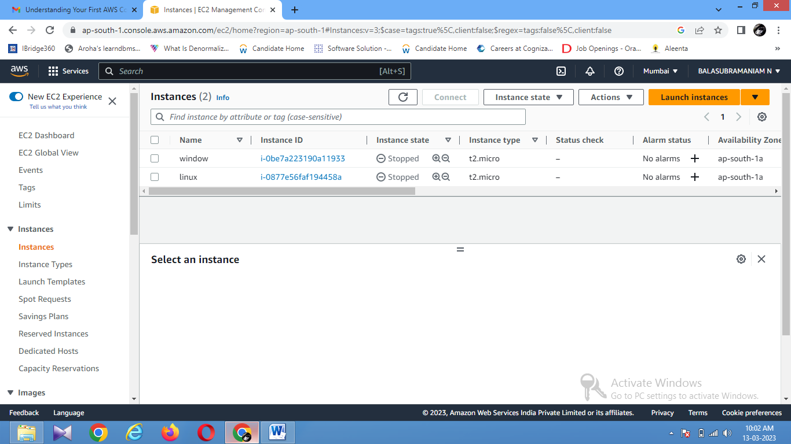

INSTANCE WAS CREATED IN AWS CLOUD COMPUTING FOR OPERATING SYSTEM OF

1)WINDOWS

2)LINUX